CST1340 Coursework Group

Group members:
# | Student Number | Full Name
1 | M01086284 | Linah Fathima
2 | M01095069 | Vibuti Patil
3 | M01039380 | Shwet Menghwani

Section 1 – HTML AND CSS

Introduction:

This section explains the HTML structure of the website and how the CSS was used to improve the appearance of the pages.

Home page:

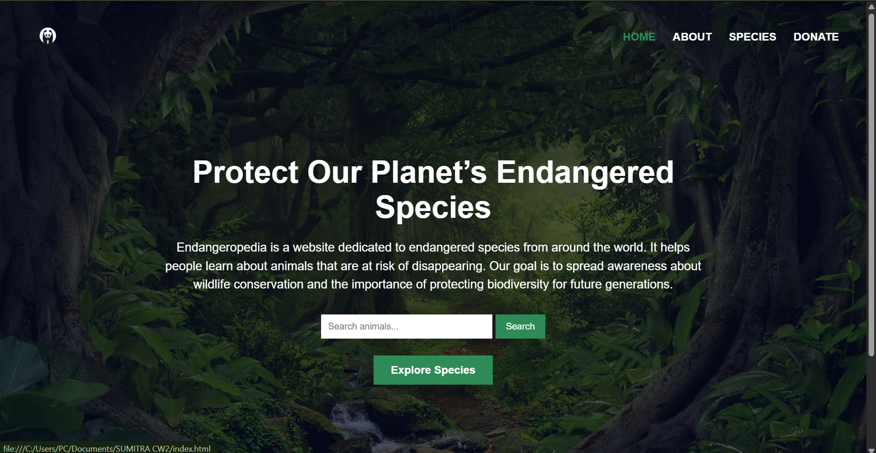

Here a navigation bar is placed at the top of the page that navigates us through home page, about page and species page. CSS was used to change the color of the font from white to green when hovered over it. A background image was used to make the page more visually attractive. A dummy search bar was also placed in the center of the page and a footer that contains contact information.

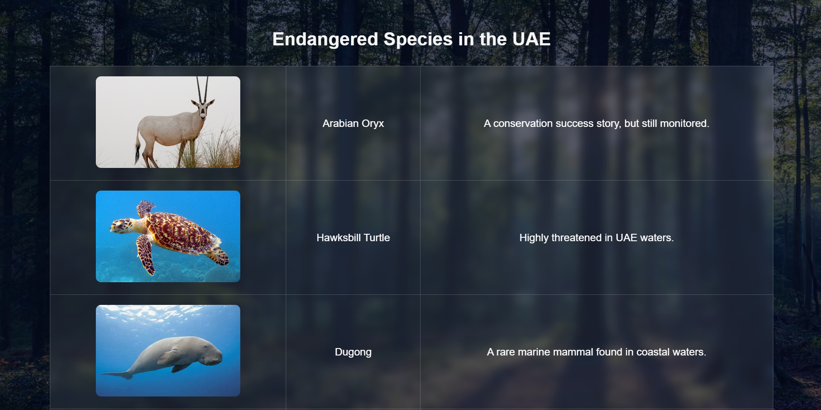

An HTML table is also included in the species section of the website that displays information about endangered species globally and in the UAE.

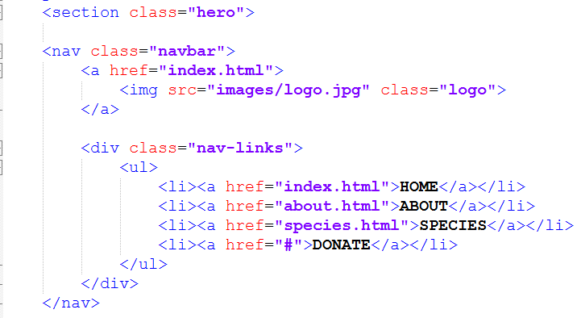

Navigation bar which helps user navigate through available pages.

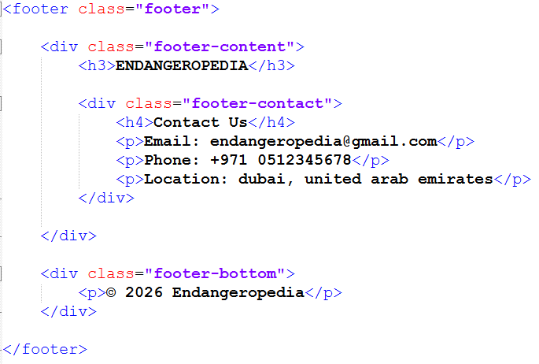

HTML codes for the footer which contains contact information and basic information about the website.
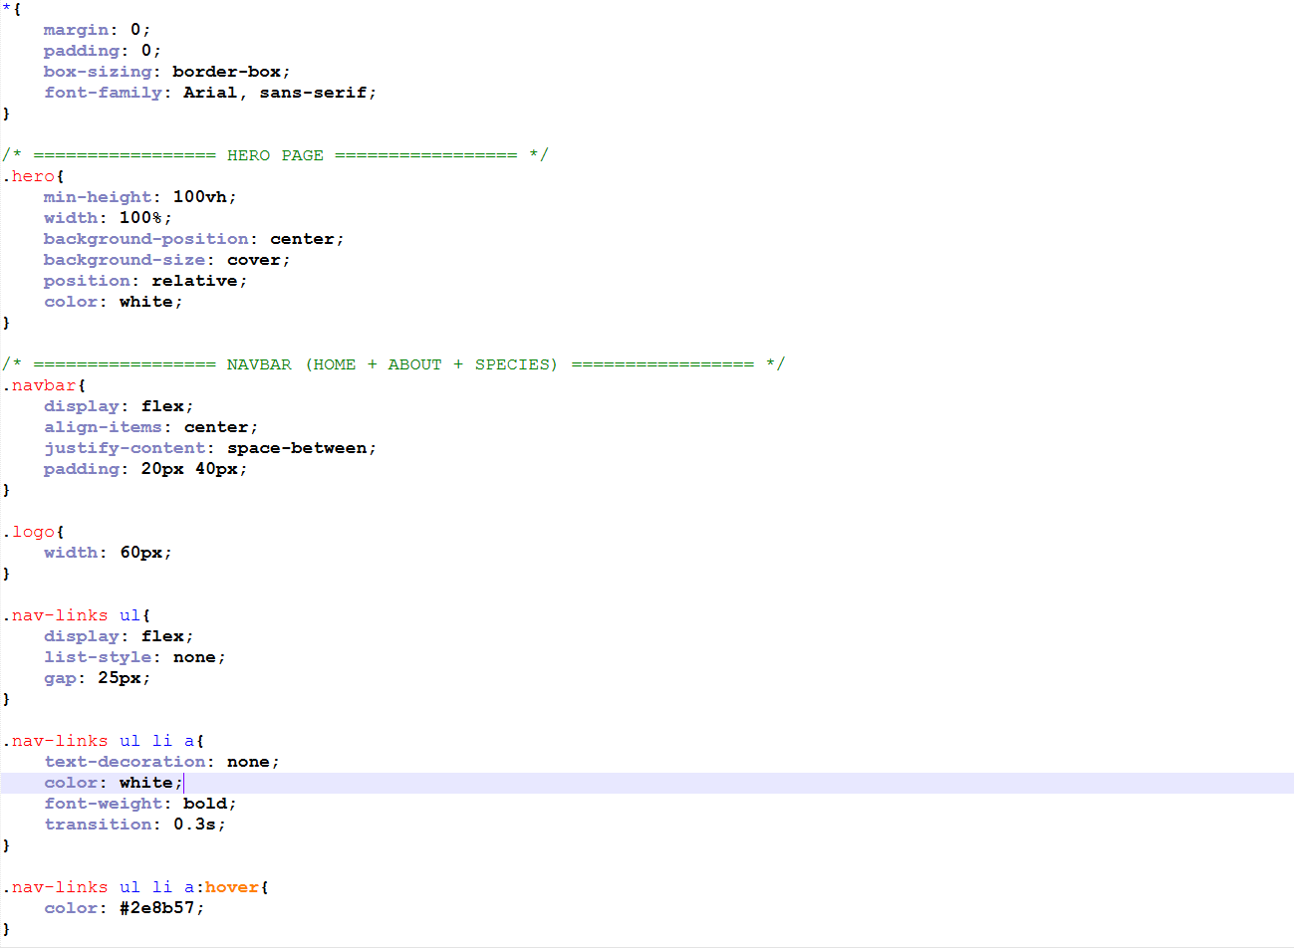

CSS was used to style the background image and make the website more visually appealing. A flexbox was used in the navigation bar with hover effects for links and buttons. Padding and margins were also used to improve spacing.

Section 2 – XML

XSD:

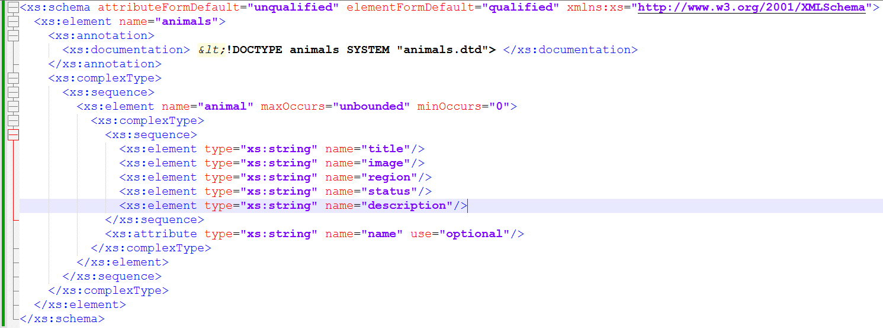

The XML file was created to store information about endangered animals from around the world and from the UAE. The root element is <animals>, which contains multiple <animal> child elements.
Each <animal> element contains:
- A name attribute to identify the animal.
- A <title> tag for the display name.
- An <image> tag for the image file name.
- A <region> tag to show where the species is found.
- A <status> tag to show the conservation level.
- A <description> tag to provide more details about the animal.

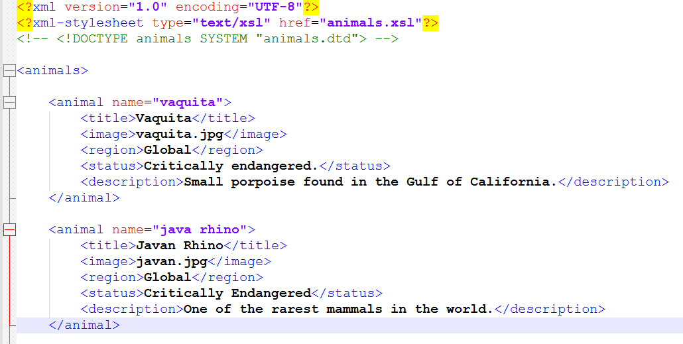

Section 3 – Validation

The DTD file validates the structure of the XML file and ensures that every animal record contains the correct elements and attributes.

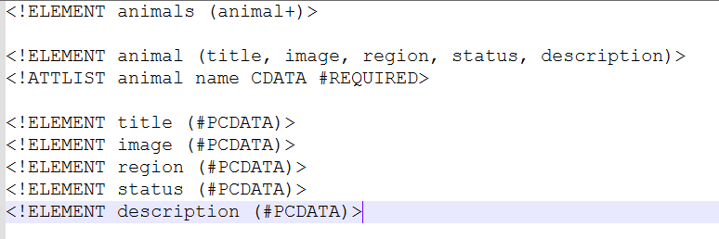

- <!ELEMENT animals (animal+)> defines animals as a container element.
- The + symbol means one or more animal elements must exist.
- <!ELEMENT animal (title, image, region, status, description)> defines animal as a container element.
- It shows that every animal must contain the five child elements in the correct order.
- <!ATTLIST animal name CDATA #REQUIRED> defines an attribute called name.
- CDATA means the attribute can contain text.
- #REQUIRED means every animal must have a name attribute.
- <!ELEMENT title (#PCDATA)> is a data element because it stores text.
- <!ELEMENT image (#PCDATA)> is also a data element because it stores the image file name.
- region, status, and description are data elements because they contain text values.
- No empty elements are used in this DTD because every element contains text or child elements.

Section 4 – Transformation

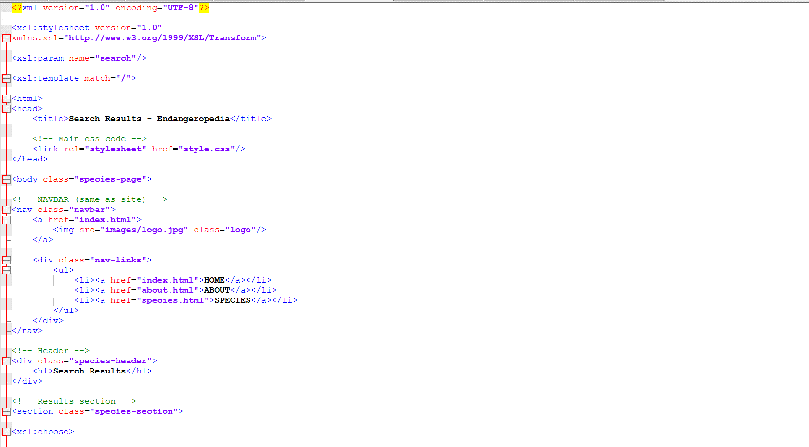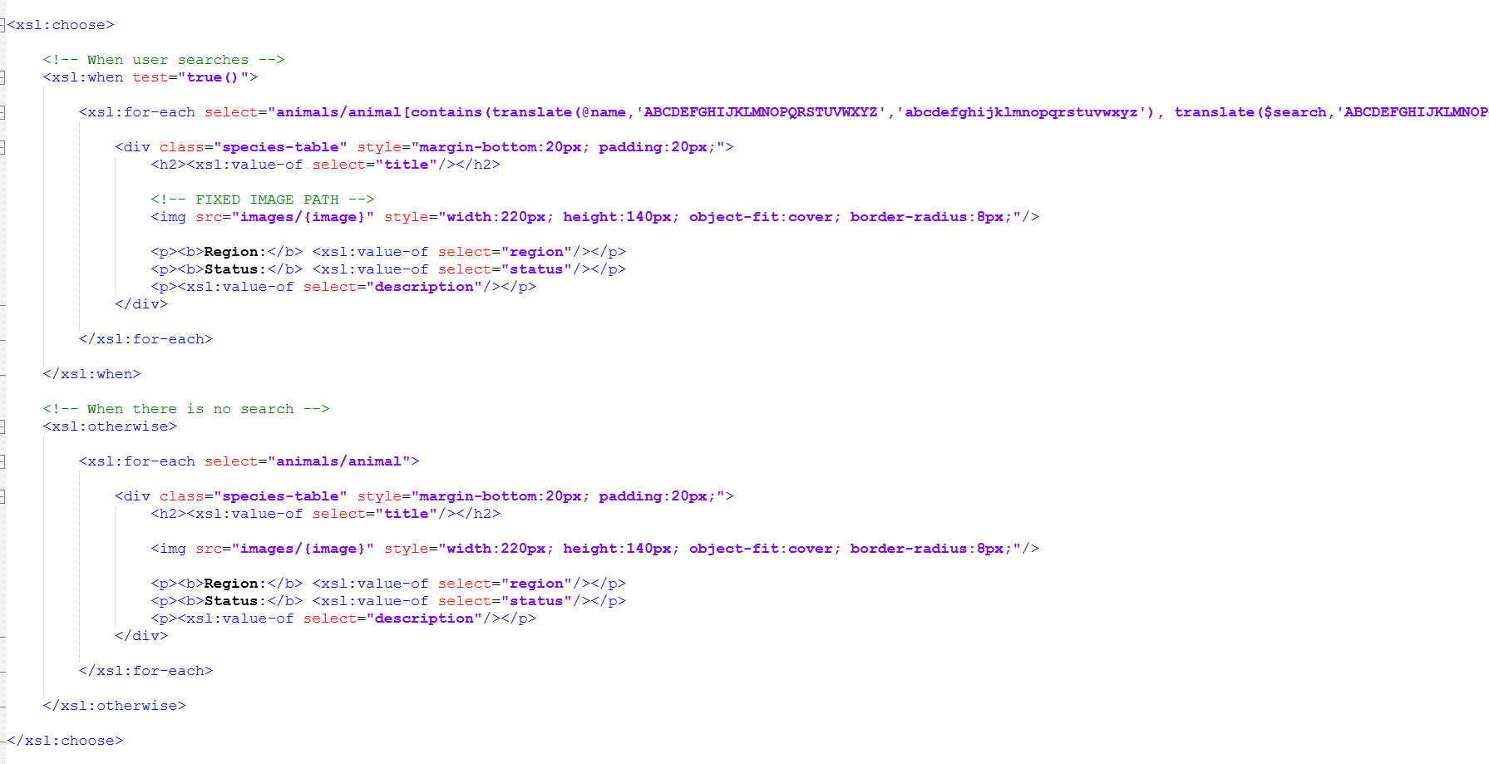

- <xsl:stylesheet> defines the document as an XSLT file.
- xmlns:xsl="http://www.w3.org/1999/XSL/Transform" is the XSLT namespace.
- <xsl:template match="/"> starts the transformation from the root of the XML file.
- <xsl:for-each select="animals/animal"> loops through each animal in the XML file.
- <xsl:value-of select="title"/> displays the animal title.
- <xsl:value-of select="region"/> displays the region.
- <xsl:value-of select="status"/> displays the conservation status.
- <xsl:value-of select="description"/> displays the description.
- <xsl:attribute name="src"> is used to set the image source dynamically.
- The XML data is transformed into XHTML format for display in a browser.

AUTHOR CONTRIBUTION

